ONLINE SHOPPING MANAGEMENT SYSTEM – SEQUENCE DIAGRAM

SUBMITTED BY K.VEDALAKSHMI - 2022503301

SEQUENCE DIAGRAM FOR USER

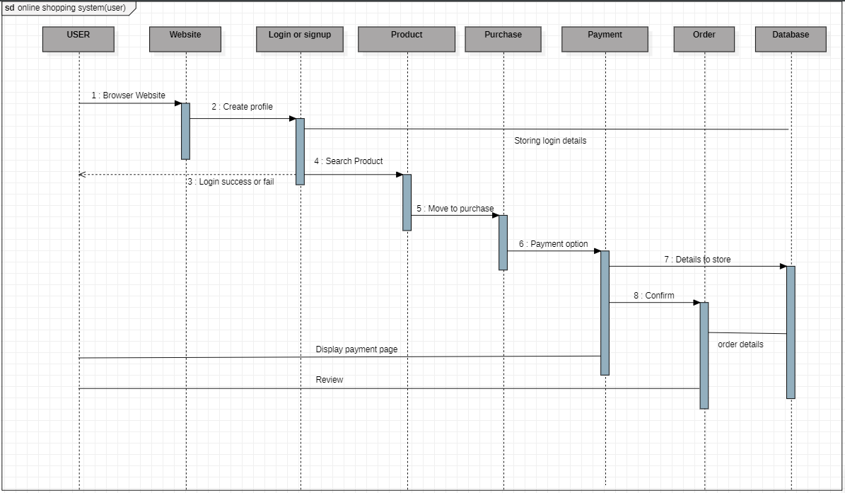

SEQUENCE DIAGRAM FOR SELLER

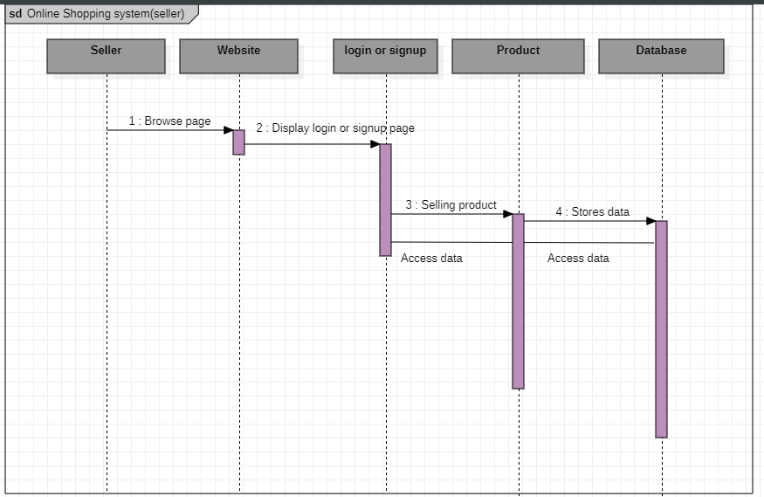

SEQUENCE DIAGRAM FOR ADMIN

